Click on the hyperlink.
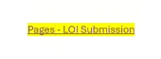
If the hyperlink does not open, please paste the address into your browser
https://connect.ncdot.gov/sites/ocr/Pages/LOI-Submission.aspx
click on the highlighted section:
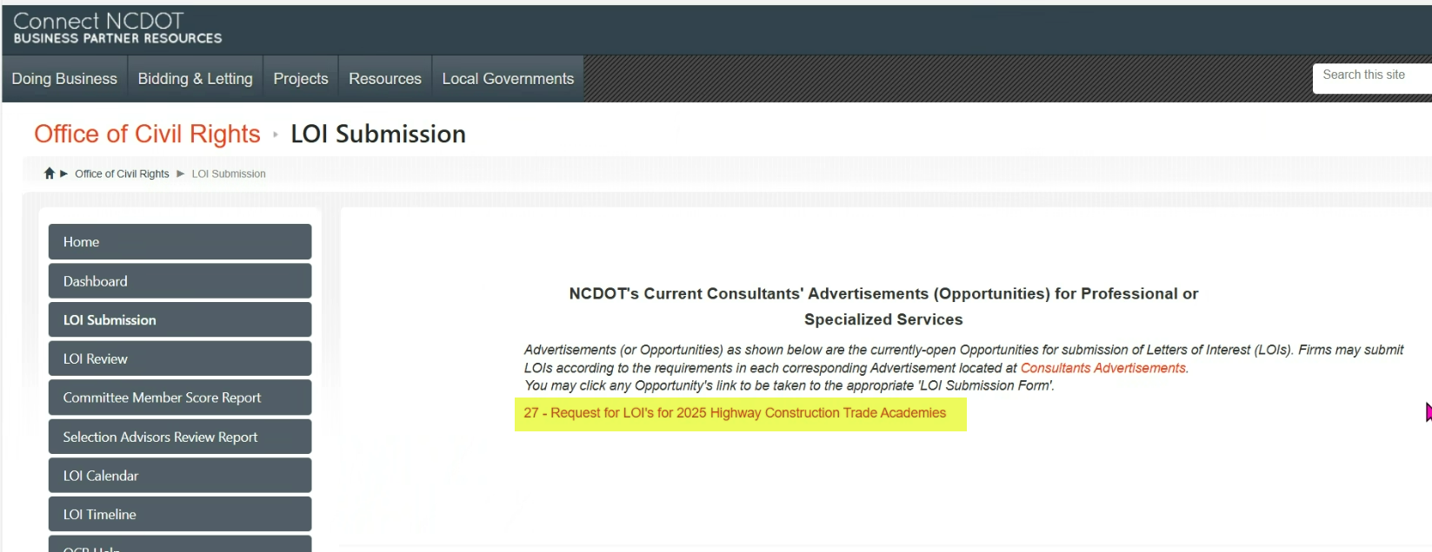
Fill out all sections, click on the upload button to upload your packet then click on the Save button.
